# Night And Day Aqua

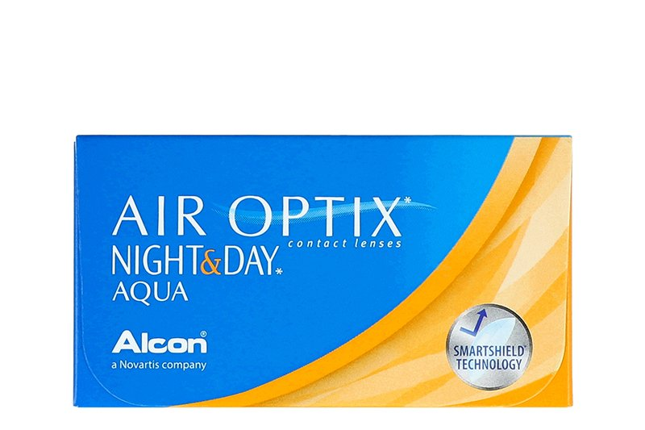

Product information

|  |  |
| --- | --- |
| **Brands** | Air Optix |
| **Availability** | In stoke |
| **Replacement** | Monthly |
| **Material** | 76% lotrafilcon A polymer, 24% H2O |

Description

**Air Optix Night and Day Aqua have replaced the former Focus Night and Day lens. You may continue to use your valid Night and Day prescriptions to order the Air Optix Night and Day Aqua. The new name/packaging reflects the improvements made to this contact lens.  
  
This lens features the new AQUA Moisture System, easier insertion, 6 lenses per box, all day and night comfort and six times more oxygen transmission compared to other lenses**.